Tertiary Species - Other Fish

Bebak et al. 2012. Pathology in Practice. JAVMA 240(7):827-831 [Goldfish]

Domain 1: Management of Spontaneous and Experimentally Induced Diseases and Conditions, Task 3. Diagnose disease or condition as appropriate

SUMMARY: An 8-year-old goldfish was noted to have a mass on the left side for the past 5 months. The mass did not appear to grow over this time. The fish was held in a pond with 80-100 other fish, and no other fish had the same type of mass. The owner elected to euthanize the fish and determine the cause of the mass.
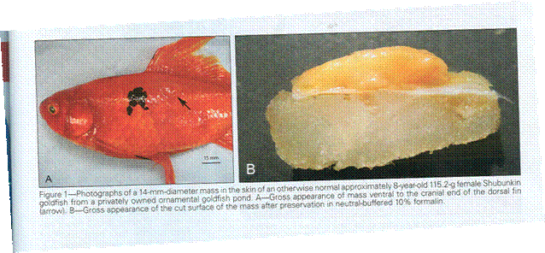
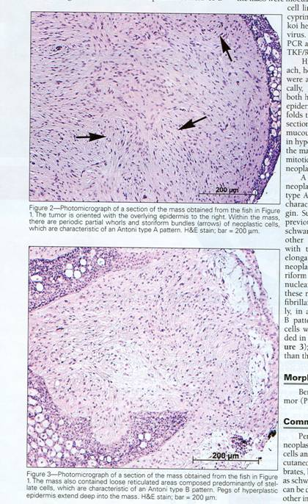

On necropsy, no other gross abnormalities were noted except for the mass. The mass was well-circumscribed, slightly raised above the skin surface. It did not penetrate the body wall. The pathologists searched for typical fish pathogens: koi herpesvirus or spring viremia of carp. An impression revealed no evidence of bacteria, fungi, or protozoa. Histological evaluation of the mass demonstrated Antoni type A and B tissue patterns, consistent with nerve sheath tumor origin. This tumor was diagnosed as a benign peripheral nerve sheath tumor (PNST). These can be either schwannomas or neurofibromas, but are hard to differentiate.

QUESTIONS
1. Zebrafish are more common than goldfish as models in biomedical research. What is the most common type of neoplasia in zebrafish?
2. Schwannomas have been detected in many other fish species. T or F
3. T or F. Cryosurgery and traditional excision are both acceptable methods for PNST removal.

ANSWERS
1. Seminomas are the most common spontaneous neoplasms observed in our diagnostic cases. In older broodstock, these neoplasms are often huge in size, causing marked abdominal distention, and constituting about half of the body mass. These neoplasms are typically soft, white, multilobulated masses and, in our experience, have always been confined to the testis. http://zebrafish.org/zirc/health/diseaseManual.php#NEOPLASTIC%20DISEASES
2. True. Goldfish, snapper, coho salmon, bicolor damselfish, rainbow smelt, zebrafish
3. True, except cryosurgery is better because there is less hemorrhage and less chance of recurrence.

Shin et al. 2011. Surgical removal of an anal cyst caused by a protozoan parasite (Thelohanellus kitauei) from a koi (Cyprinus carpio). JAVMA 238(6):784-786

SUMMARY: An 8-month-old koi (Cyprinus carpio) fish (weighed 38.9g) was examined at for anal obstruction. The affected fish was lethargic and anorexic, appeared depressed, and had a nodular obstruction at the anus. A biopsy specimen from the anal mass was submitted for histologic examination, which revealed a number of protozoa. On the basis of the morphological characteristics of the spores (spores were pyriform, with a sharply tapered cranial portion and a rounded caudal portion) and the location of the plasmodia (i.e., vegetative form of the parasite), a diagnosis of a cyst containing Thelohanellus kitauei was made. Thelohanellus kitauei is a protozoan parasite that affects freshwater fish by producing cyst-like tumors that may cause intestinal obstruction. Thelohanellus kitauei infection with cystic disease has been reported to affect Cyprinus spp worldwide.

Treatment: The fish was anesthetized by use of tricaine methane sulfonate and the cyst was removed surgically. After surgery, low-concentration tricaine methane sulfonate immersion was used for sedation and antimicrobial treatment was administered. The surgical wound healed completely, and the fish was clinically normal 14 months after surgery.

QUESTIONS:
1. What is the anesthetic that was used to anesthetize the fish?
2. How was anesthesia introduced to fish?
3. What characteristics were helpful in identifying the Thelohanellus species?
4. What type of a parasite is Thelohanellus kitauei?

ANSWERS:
1. Tricaine methane sulfonate
2. Characteristics of the spores (spores were pyriform, with a sharply tapered cranial portion and a rounded caudal portion) and the location of the plasmodia.
3. Anesthesia was induced by immersing the fish in water containing 200 mg of tricaine methane sulfonate/L for 5 minutes.
4. Protozoan parasite

Lamm et al. 2011. Pathology in Practice. JAVMA 238(6):703-706

SUMMARY: This is an article that discusses finding of the necropsy of a large mouth bass (Micropteru salmoides).

History: Several fish were found dead in a pond within a cattle grazing area (800 beef cattle use this range). The farmer had note that 3 cattle had stillbirths; the cattle were also seen to be standing/wading in the same pond where the dead fish were found.

Main Findings Of The Gross Pathology: Within the coelomic cavity, there were dozens of 1cm-long, coiled, thin nematodes embedded within the serosa of coelomic organs (Figure A). Rare, flat white 3 to 5 cm long cestodes were also identified free within the coleomic cavity. The intestinal loops were loosely adhered together with fibrin. There were approximately 12 white areas (pinpoint to 2 mm in diameter) within the liver.

Histopathology of Micropterur salmoides: Within the wall of the intestine there were multiple 100 um nematodes detected. The cestodes that were free within the coelomic cavity were 1mm in width lacked a body cavity or digestive tract, and had calcareous corpuscles within the parenchyma (picture not shown).

Nematode Identification: the parasites had 3 lips, esophageal ventriculus, anteriorly directed intestinal appendix and a lack of reproductive organs. On the basis of these findings and the host species, the parasites were identified as anisakid larvae, most likely Contracaecum spp.

Necropsy of one of the stillborn calves revealed head trauma as the cause. Serum was collected from the second calf and tested negative for Leptospirosis, Brucellosis, and Bovine herpesvirus, and bovine diarrhea virus, Campylobacter spp culture was negative, no cause of death was identified. No link to the stillborn calves and the dead fish found.

Morphologic Diagnosis: Granulomatous coelomitits, hepatitis, enteritis with intralesional nematodes and free cestodes within the coelom

The anisakid larvae were considered incidental findings in these fish - the cause of death is unknown.

Other Comments Included: Other differential diagnosis for granulomas in the coelomic cavity include bacterial (Mycoplasma most common) or parasitic infections.

QUESTIONS:
1. Which combination of parasites is most commonly associated with disease in fish?
a. Nematodes and cestodes
b. Protozoal and trematode
c. Cestodes only
d. Nematodes only
2. Which of the following is NOT true for parasites classified as anisakids?
a. They become third- stage larvae in invertebrate hosts such as shrimp, scallops, and mussels
b. Fish can act as both paratenic and intermediate hosts for anisakids
c. There are no known species that infect humans
d. The eggs are passed into the environment from the host during defecation
3. What type of stain is used to identify Mycobacterium for tissue histopathology?
a. Acid fast stain
b. Giemsa
c. PAS
d. Hemotoxylin and eosin

ANSWERS:
1. B
2. C
3. A

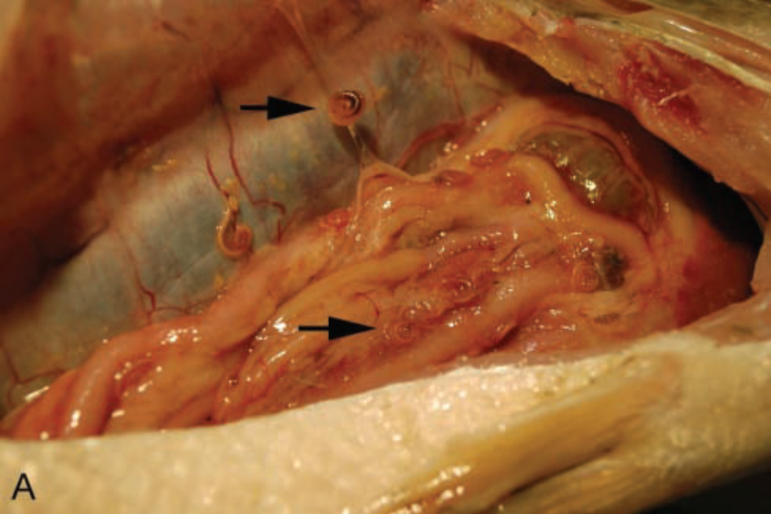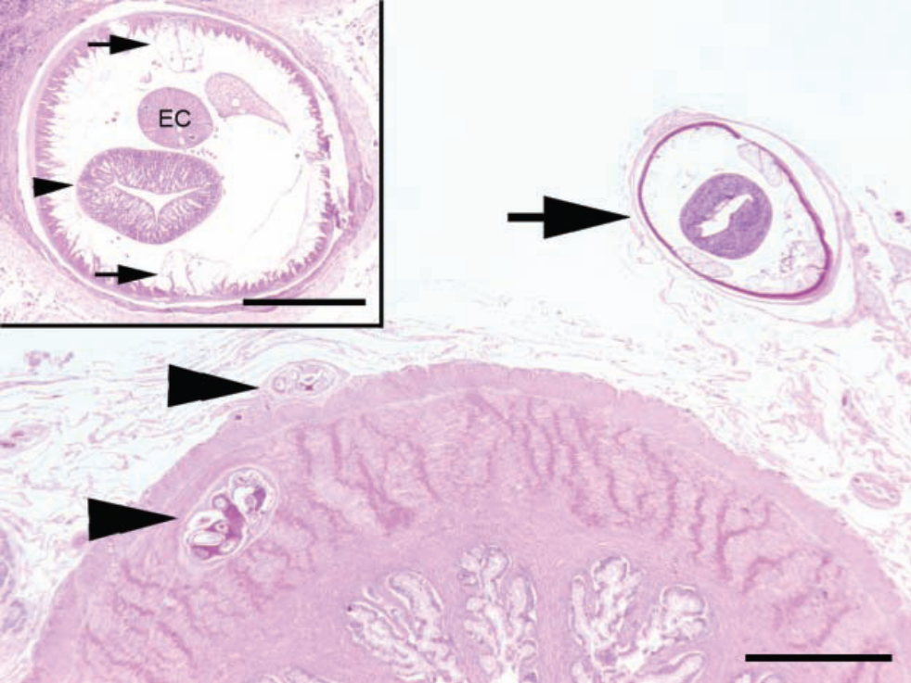

Within the wall of the intestine there were multiple 100 um nematodes detected. The cestodes that were free within the coelomic cavity were 1 mm in width, lacked a body cavity or digestive tract, and had calcareous corpuscles within the parenchyma (picture not shown).

Nematode identification - The parasites had 3 lips, esophageal ventriculus, anteriorly directed intestinal appendix, and a lack of reproductive organs. On the basis of these findings and the host species, the parasites were identified as anaisakid larvae, most likely Contracaecum sp.

Kubiski et al. 2011. Pathology in Practice. JAVMA 238(3):301-304
Domain 1: Management of Spontaneous and Experimentally Induced Diseases and Conditions; K3 - Parasitology with emphasis on parasitic diseases that can become established in a colony and zoonotic parasitic diseases

Tertiary Species: Other Fish

SUMMARY: Squarespot anthias are Indo-Pacific marine tropical fish, common in the pet industry. A group of approximately 700 animals was wild-caught and imported. They were housed in a closed, recirculating system during quarantine. During the first week, a low level of mortality occurred, but the mortality rate accelerated dramatically over the next 5 days despite application of trimethoprim-sulfathiazole beginning on day 1. The housing tank had been scrubbed and disinfected prior to arrival. Water quality parameters were within normal limits. 8 dead fish were submitted to the University of Georgia, Department of Pathology. It was extraordinarily difficult to collect or identify individually affected fish prior to death.

Gross necropsy showed inconspicuous pale epithelial erosions and ulcers of varying size. There were not any notable internal abnormalities and bacterial cultures showed no growth. A skin scrape identified a highly motile, holociliated, oval to pyriform protozoan consistent with scuticociliates. The ciliate parasite was mostly found in the areas of necrosis and ulceration. There was ciliate invasion of muscular tissue identified with staining. Inflammation was minimal.

At the conclusion of the appropriate therapeutic regimen (copper sulfate, chloroquine, and metronidazole) 85% of 700 fish died. The timing suggests that the animals came in with a low level of parasitism from the wild which became exacerbated from shipping stress. The antibiotic applied initially had limited benefit against this parasite. Scuticociliates appear to have little host specificity and can infect many species. They are fairly amenable to treatment if identified early and treated with appropriate therapeutics (e.g. malachite green, copper sulfate, methylene blue, nitrafurazone, and formalin.)

QUESTIONS:
- T/F. Ectoparasites, including scuticociliates, typically affect single animals and rarely spread to large groups of fish.
- T/F. Scutociliates show little host specificity and can infect many different fishes, including different species in the same tank or system.

ANSWERS:
- F
- T

Hanley et al. 2010. Effects of anesthesia and surgery on serial blood gas values and lactate concentrations in yellow perch (Perca flavescens), walleye pike (Sander vitreus), and koi (Cyprinus carpoi). JAVMA 236(10):1104-1108

Domain 1; K1diagnostic procedures, clinical pathology

SUMMARY: In order to determine if there is an association between high blood lactate concentrations and poor survival outcomes post surgery blood samples were collected from fish at 3 time points: before anesthesia, during anesthesia, and after surgery. These blood samples were analyzed for blood gas values and lactate on a handheld blood analyzer. The fish were then monitored for 2 weeks post-op. All walleye (5) and koi (8) survived, but 2 perch died (out of 10). Blood P_{CO2} decreased significantly in perch from before anesthesia to immediately after surgery, and also from during anesthesia to immediately after surgery, whereas blood P_{CO2} decreased significantly in koi from before to during anesthesia. Blood P_{O2} increased significantly in both perch and koi from before to during anesthesia, and also in koi from before anesthesia to immediately after surgery. For all 3 species, blood lactate increased significantly from before anesthesia to immediately after surgery. Blood lactate immediately after surgery for the 8 surviving perch (6.06+/-1.47mmol/L) was significantly lower than blood lactate in the 2 perch that died (10.58 and 10.72mmol/L). Elevated blood lactate concentrations immediately after surgery ( 10mmol/L) may be predictive of a poor short-term survival rate in yellow perch.

QUESTIONS:
1. Which of the following blood gas values is not temperature dependent?
- pH
- Lactate
- PO₂
- PCO₂
2. Why were mixed venous arterial samples obtained from fish for blood gas analysis?

ANSWERS:
- b.
- Fish arteries and veins are thin-walled so peripheral collection typically results in a mixed venous-arterial sample.

Nolan et al. 2010. Pathology in Practice. JAVMA 236(6):631-635 [Goldfish]

Domain 1: Management of Spontaneous and Experimentally Induced Diseases and Conditions. K3&5 – parasitology & anatomic pathology.

Tertiary Species – Other Fish

SUMMARY: Case report of a 7- month old goldfish bought about 1 month earlier. Presented with a rapidly enlarging mass that affected the oral cavity and left operculum. Associated clinical signs included: left opercular flaring, progressive gill pallor, let-sided exophthalmia, and suppressed appetite.

Physical Exam: soft, nodular, pink mass was detected in close association with the ventral aspect of the left gill arch.

Work-up: Buffered tricaine methanesulfonate (75mg/L) used as anesthesia. Excisional biopsy sample for smears and pathology.

Cytological and Histopathological Findings: On the impression smears stained with a Romanowski-type stain a moderate number of heterophils and a large number of myxosporean spores were found. Spores were 8-10 μm long by 5 μm wide and had a 1 μm-think basophilic teardrop-shaped capsule. Each spore had a 2 intensely basophilic, piriform, apical polar capsule with occasionally extruded polar filaments and 1 basally located sporoplasm.) -

Morphologic Diagnoses: Severe, chronic, focal, granulomatous, nodular, and ulcerative stomatitis with myxosporidia (Myxobolus spp).

Comments: Myxobolus cerebralis is one of the most important members of this type of parasites. It causes “whirling disease”; a very important disease of salmonids. It has a complicated life cycle involving an oligochaete worm, which acts as an intermediate host. The worm release spores that enter the skin of fish, migrate through the nervous system as trophozoites and eventually reach their target tissue, cartilage. In cartilage trophozoites develop into plasmodia and spores are released from the fish at death.

Differential Diagnoses: Neoplasia and a granulomatous disease such as Mycobacterium spp.

Poor feeding practices at farm level perpetuates the spread of these parasites.

Treatment is Difficult: Furazolidine, and fumagillin. And enrofloxacin (5mg/kg) for secondary bacterial infections.

QUESTIONS:
- Mention 3 differential diagnoses for an oral nodular granulomatous mass on fish.
- What is the causative agent for “whirling disease” in salmons?

ANSWERS:
- Parasites (Myxobolus spp), neoplasia and granulomatous disease (Mycobacterium spp)
- Myxobolus cerebralis

Boone et al. 2008. Comparison between coelioscopy and coeliotomy for liver biopsy in channel catfish. JAVMA 233(6):960-967

Task 1 – Prevent, Diagnose, Control, and Treat Disease
Tertiary Species - Fish

SUMMARY

Introduction - The purpose of the study was to evaluate liver biopsy performed via coelioscopy and coeliotomy in channel catfish.

Materials and Methods - Thirty reproductively inactive subadult farmed catfish were used in the study. Fish were randomly allocated to 3 treatment groups: control, coeliotomy, and coelioscopy. Groups were housed in separate tanks. Anesthesia was induced by use of a 15-gallon tank using tricaine methane sulphonate buffered with sodium bicarbonate to maintain a pH of 6.5 to 7.2 in maintenance tank water. Each fish was then moved to a water-recirculating anesthesia machine and maintained with tricaine methane sulphonate buffered with sodium bicarbonate.

Ten fish underwent coeliotomy and liver biopsy. An 8- to 10-cm ventral midline incision was made and a brief evaluation of visible viscera (stomach, liver, gallbladder, small intestine, and spleen) was performed. A liver biopsy specimen was collected via a standard suture loop technique and 3-0 polydioaxanone suture. The body wall was closed in a single layer with 3-0 polydioaxanone suture in a simple interrupted pattern.

Ten fish underwent coelioscopy and liver biopsy through a 4-mm skin incision in the ventral midline. A 2.7-mm X 18-cm 30-degree rigid endoscope was inserted into the incision. Sterile saline (0.9% sodium chloride) solution was infused into the coelom to permit evaluation of visible viscera (stomach, liver gallbladder, cranial and caudal kidneys, gonads, small and large intestine, spleen, swim bladder, and urinary bladder). Two liver biopsy specimens were collected, the endoscope was removed, saline solution was gently expressed from the coelom, and the incision was closed with a single simple interrupted 3-0 polydioaxanone suture.

Ten fish in the control group did not undergo a surgical procedure, but were anesthetized for blood collection and maintained under anesthesia for 10 minutes. Each fish in the coeliotomy and coelioscopy groups received meloxicam (0.2 mg/kg), IM, before recovery from anesthesia. On day 14, all remaining fish were euthanized; a gross necropsy was performed on each fish and tissue samples were obtained for histological examination. Biopsy specimens and necropsy tissues were stained with H&E stain and objectively assessed and scored for the extent of melanomacrophage aggregates, mononuclear cellular infiltrates, crush artifact, and necrosis.

Results - Cranial and caudal kidney, gonads and reproductive tract, terminal portion of the large intestine, and caudal fat body could only reliably be examined via coelioscopy. Both techniques yielded biopsy specimens of moderate to good diagnostic quality. At necropsy, 3 of 10 coeliotomy-treated fish had developed severe wound dehiscence; all incisions in the coelioscopy group healed without incident. More extensive and severe histology abnormalities were detected after coeliotomy, compared with control and coelioscopy groups. Bacterial cultures were not performed. No significant differences were detected between coeliotomy and coelioscopy groups for anesthetic induction, or surgery or recovery times.

Discussion - Coelioscopy permitted a more complete examination of the coelom, gonads, cranial and caudal kidney, caudal portion of the intestinal tract, and urinary bladder. Crush artifact was greater in the biopsy specimens obtained via coelioscopy; however, both procedures provided samples of diagnostic quality. Coeliotomy resulted in complete dehiscence in 3 of 10 fish. During the study, control fish gained 12% of body weight, whereas fish undergoing coeliotomy lost 30% of body weight, and fish undergoing coelioscopy group lost 4% of body weight. Four fish in the coeliotomy group, 3 in the coelioscopy group, and 3 in the control group died during the study.

Results indicated that both procedures are practical in catfish, coelioscopy enabled a more complete and detailed examination of the coelom, was faster, less traumatic, and resulted in decreased wound dehiscence and postoperative sepsis.

QUESTIONS:
- What anesthetic was used to induce and maintain anesthesia in catfish?
- Which procedure resulted in wound dehiscence in greater numbers of fish?
- Which procedure resulted in a greater amount of crush artifact of the biopsy specimen?

ANSWERS:
- Tricaine methane sulphonate buffered with sodium bicarbonate.
- Coeliotomy
- Coelioscopy

Intorre et al. 2007. Tolerance of benzalkonium chloride, formalin, malachite green, and potassium permanganate in goldfish and zebrafish. JAVMA 231(4):590-595.

Task 1. Prevent, Diagnose, Control, and Treat Disease
Task 3. Provide Research Support, Information, and Services
Species: Secondary (zebrafish) and Tertiary (goldfish)

SUMMARY: Disinfectants are commonly used for the treatment of infectious diseases in ornamental fish; however the available published dosages have often been determined on the basis of empirical and anecdotal information. The authors wanted to determine the tolerance of goldfish and zebrafish to benzalkonium chloride, formalin, malachite green, and potassium permanganate. Goldfish (Casassius auratus) and zebrafish (Danio rerio) were chosen as representatives of cold-water and warm-water species, respectively.

The disinfectants were chosen for this study because they represent commonly used disinfectants belonging to different classes with different modes of action.

Disinfectant |  | Effects
benzalkonium chloride | Mixture of quaternary ammonium compounds | B, F, V
formalin | Saturated (37%) aqueous solution of formaldehyde | P, skin and gill flukes, also B, F, V
malachite green | Toxic chemical used as a dye | Diluted used to treat F, P
potassium permanganate | A salt | P and monogean parasites, bacterial gill disease
B = Bactericidal, F = Fungistatic, V = Virucidal, P = protozoal infections

Study design: Groups of fish (n = 10/group) were exposed to each disinfectant at the therapeutic dosage; at 0.25, 0.5, 3, and 5 times the concentration used for the therapeutic dosage; and at the concentration used for the therapeutic dosage but for 3 or 5 times the recommended exposure time.

Results: In both species, exposure to malachite green at the therapeutic dosage resulted in toxic effects, including death. Exposure to formalin at the therapeutic dosage resulted in toxic effects in goldfish, but not zebrafish, and exposure to potassium permanganate resulted in toxic effects in zebrafish, but not goldfish. On the basis of the ratio of therapeutic dosage to median lethal dosage, in goldfish, formalin was more toxic than benzalkonium chloride, which was more toxic than malachite green, which was more toxic than potassium permanganate. In zebrafish, potassium permanganate was more toxic than formalin and benzalkonium chloride, which were approximately equally toxic and more toxic than malachite green. Extending treatment time increased the toxicity of potassium permanganate in zebrafish and the toxicity of formalin and malachite green in goldfish, but did not alter the toxicity of the other disinfectants.

Conclusions and Clinical Relevance: Results indicated that there was no consistency between zebrafish and goldfish in their tolerance to disinfectants, and that therapeutic dosages reported in the literature for these disinfectants were not always safe.

QUESTIONS:
1. Zebrafish are a ____-water species, with the water temperature maintained between ___ and ____° F.
2. Which disinfectant was the most toxic in goldfish, based on the ratio of therapeutic dosage to median lethal dose?
3. Which disinfectant was the most toxic in zebrafish, based on the ratio of therapeutic dosage to median lethal dose?

ANSWERS:
1. Warm-water, 75° and 79°F
2. In goldfish, formalin was more toxic than benzalkonium chloride, which was more toxic than malachite green, which was more toxic than potassium permanganate.
3. In zebrafish, potassium permanganate was more toxic than formalin and benzalkonium chloride, which were approximately equally toxic and more toxic than malachite green.

Bebak et al. 2007. Improved husbandry to control an outbreak of rainbow trout fry syndrome caused by infection with Flavobacterium psychrophilum. JAVMA 231(1):114-116.

SUMMARY: A trout farm in West Virginia reported a 2 week history of anorexia, lethargy, exophthalmia, labored respiration, and a mortality rate of 0.28% after visiting students used equipment to measure water quality in some tanks. The pattern of spread coincided with the cleaning routine used by personnel. In affected tanks 5-10% of the fish appeared to be abnormal. Necropsy results revealed pale red gills and kidneys, red-tinged coelomic fluid and pale brown kidneys. Histological findings were consistent with bacterial septicemia (pyogranulomatous inflammation with clusters of bacilli), with lesions affecting the spleen, heart, gills, bone, and cartilage. Lesion distribution was consistent with Flavobacterium psychrophilum. Three Flavobacterium isolates were obtained from culture. Rather than treat with antibiotics, the farmer chose to treat by decreasing pathogen load. All dying fish were removed, and separate equipment was used for each tank. The farmer used chlorine containing rinse buckets and transferred fish to tanks that were cleaned with chlorine and surfactant.

QUESTIONS:
1. Flavobacterium psychrophium is the cause of what two common salmonid diseases?
2. Clinical signs and mortality rates of F. psychrophilum have been related to which factors?
a. Fish size
b. Fish age
c. Water temperature
d. All of the above
3. What differentials should you consider for septicemia in rainbow trout fry?
a. Infectious pancreatic necrosis
b. Infectious hematopoietic necrosis
c. BCWD
d. RTFS
e. All of the above

ANSWERS:
1. BCWD (Bacterial coldwater disease) and RTFS (rainbow trout fry syndrome)
2. d
3. e

Haskell et al. 2004. Current approved drugs for aquatic species. JAVMA 224(1):50-51.

SUMMARY: Ensuring preharvest food safety and preventing illegal drug residues are important issues when selecting therapeutic regimens for aquatic species. Currently available therapeutic substances used in aquaculture can be classified as FDA-approved drugs, FDA-unapproved low-regulatory-priority treatments (LRPTs), Environmental Protection Agency (EPA)-registered products, USDA-licensed biologics, and feeds. Extra-label use of drugs in feed formulations is illegal in aquatic species raised for food. However, veterinarians may use extra-label treatments in the feed of minor species on a limited basis if they follow criteria outlined by a recent compliance policy guideline (Food Animal Residue Avoidance Databank Digest).

The FDA has not approved a number of substances used to treat diseases and to enhance production in aquatic species. However, the FDA has reviewed the use of a number of these compounds and has classified them as new animal drugs of low priority (LRTPs). The FDA will not likely object to the use of these substances if the following criteria are met: 1) substances are used for specific indications, species, and life stage(s); 2) substances are used according to good management practices; 3) product is of an appropriate food or medical grade for use in food-producing animals; 4) substance is used at prescribed dosages; and 5) adverse effects on the environment must be negligible. The FDA’s position on LRTPs should not be misinterpreted as an approval or support of safety or effectiveness. These substances must comply with the EPA’s National Pollutant Discharge Elimination System requirements.

Clove oil is being used as an anesthetic agent for fish. There is evidence in laboratory animals that clove oil is carcinogenic. Neither clove oil nor its active components may be used in food animals such as fish that could be consumed by humans.

The Animal Medicinal Drug Use Clarification Act (AMDUCA) specifically prohibits the extra-label use of an approved new animal drug or human drug in or on an animal feed. However, for some minor species, the FDA has determined that for a few approved drugs, the only practical method of delivery is in the feed. For these situations, the FDA’s Center for Veterinary Medicine (CVM) has adapted a new Compliance Policy Guide (CPG) for the extra-label use of meds in feed. This policy does not make the practice of extra-label drug administration in feed legal but the FDA will not consider regulatory actions if certain conditions are met. In an aquatic species, the extra-label use of medications added to feed is limited to products approved for use in other aquatic species. Additionally, a valid veterinarian-client-patient relationship must exist. All the usual record keeping and extended withdrawal requirements still apply. Any liability rests with the practitioner and the producer. The EPA has registered a number of products, including algaecides, herbicides, and fish toxicants. It is illegal to use EPA registered products in an extra-label manner.

Appendix 1 lists Food and Drug Administration-approved aquaculture new animal drugs. Appendix 2 lists nonapproved drugs of low regulatory priority.

QUESTIONS:
1. What does the Food Animal Residue Avoidance Databank Digest review with respect to aquatic species?
2. What are the active components of clove oil?
3. What does the AVMA panel on euthanasia have to say about the use of clove oil for euthanizing fish?
4. What federal regulation defines extra-label drug use in animal species?

ANSWERS:
- Drugs currently approved for use in aquatic species, chemicals that are not approved but are considered by the FDA’s Center for Veterinary Medicine (CVM) to be of low regulatory priority, and policies that can affect the use of these products.
- Eugenol, isoeugenol, methyleugenol
- Use of clove oil for euthanasia of fish is considered unacceptable.
4. Animal Medicinal Drug Use Clarification Act

Smith. 2002. Nonlethal clinical techniques used in the diagnosis of diseases of fish. JAVMA 220(8):1203-1207.

SUMMARY: This article describes several common clinical techniques that can be performed on unanesthetized or lightly sedated fish. To begin, it is recommended that the aquarium water quality be checked for temperature, pH, ammonia, nitrites, nitrates, and salinity.

When handling fish, latex gloves rinsed of any powder should always be worn to decrease abrasive and drying trauma to the skin and decrease transmission of zoonotic diseases. The most commonly used anesthetic method is to directly immerse the fish in an aerated buffered solution of tricaine methane sulfonate (MS-222). Typically, sedation is reached within 3-5 minutes at a dose of 20-50 mg MS-222/L of water. Surgical plane can be reached within 5-10 minutes at a dose of 50-100 mg MS-222/L of water. A fresh container of water should always be available for immediate recovery.

Skin biopsy/mucus smear: Performed by gently scraping (cranial to caudal) on the surface of the fish with the edge of a coverslip. The sample should be prepared as a wet mount and examined for protozoa, metazoan parasites, fungal hyphae, or bacteria.

Fin biopsy: Performed by cutting a small piece of tissue from the peripheral edge of 1 of the fins or the tail. A wet mount should be prepared and examined under the microscope.

Sampling of gill or skin lesions for bacterial isolation: samples are obtained from the external surface of the gills or skin and then inoculated into standard bacterial agars for growth at room temperature (most bacterial pathogens have an optimal growth rate at room temp (18-25 C)).

Gill biopsy: Performed by inserting the tip of a fine scissors into branchial (gill) cavity behind the operculum (gill cover) and cutting off the distal ends of several of the gill lamellae. A wet mount of the sample is evaluated under the microscope for external pathogens.

Fecal examination: Accomplished with the same techniques used in mammals - direct smear, standard flotation/sedimentation. Sample is evaluated for presence of protozoa, parasite eggs and larvae.

Blood sampling: Larger fish may be bled directly from the heart or from the caudal tail vessels with a syringe and needle. Fish blood coagulates rapidly; thus it is important to use heparinized syringes and needles to obtain a proper sample.

Tissue and fluid aspiration techniques: Abdominal fluid samples are performed by inverting the sedated fish so that viscera falls away from the ventral abdominal wall and inserting a 23- to 25 g needle under the ventral scales into the posterior abdominal cavity.

Radiography: Accomplished by placing the (sedated) fish on a piece of Plexiglas over a film cassette containing a high-detail film.

QUESTIONS:
1. Name the most commonly used anesthetic in fish.
2. True or False. Fish blood coagulates very rapidly so heparinized needles and syringes are necessary to obtain a proper sample.

ANSWERS:
- MS-222
- True

